Exp no:3 Spectrum Analysis of Sub-1 GHz, Mid-band & mm Wave by plotting propagation loss
Objective 1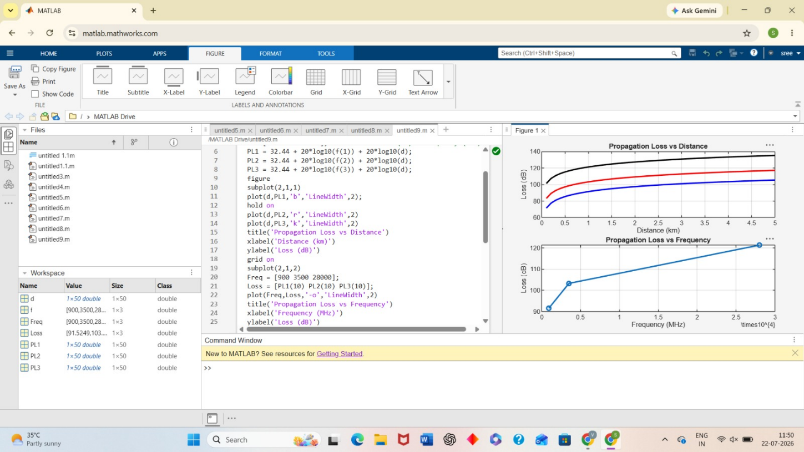
Objective 2
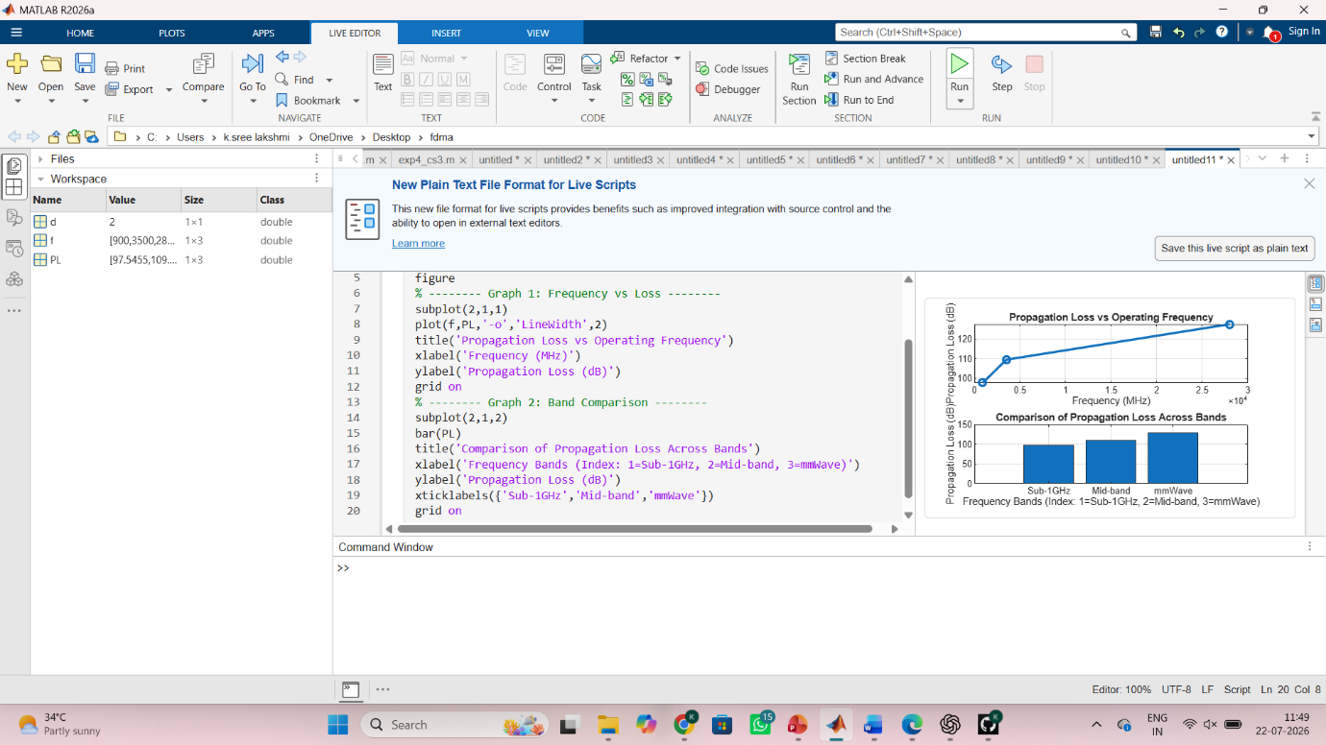
Objective 3
